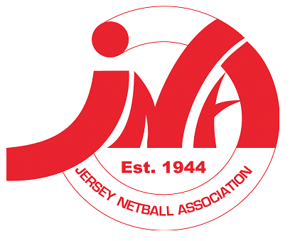
Youth Netball Update,

Hi Everyone,
We are edging closer to the launch of our Youth NETS programme starting 14th September 2022.

We want this year’s signing up and registration process to be as smooth as possible for you all, so
we are sending some information early to ensure we all understand how to get your daughter registered as a member of England Netball and also a member of Jersey Netball.

England Netball Membership REGISTRATION
This link will go live on 1st August 2022, and it is MANDATORY that you sign up to England Netball
in order to be able to participate in our new Youth NETS programme.

How To Sign Up
Please follow the hyperlink below:
England Netball | Become a Member
**FYI - The total membership for 10–14-year-olds is £25**
Click on become a member (screen shot below)
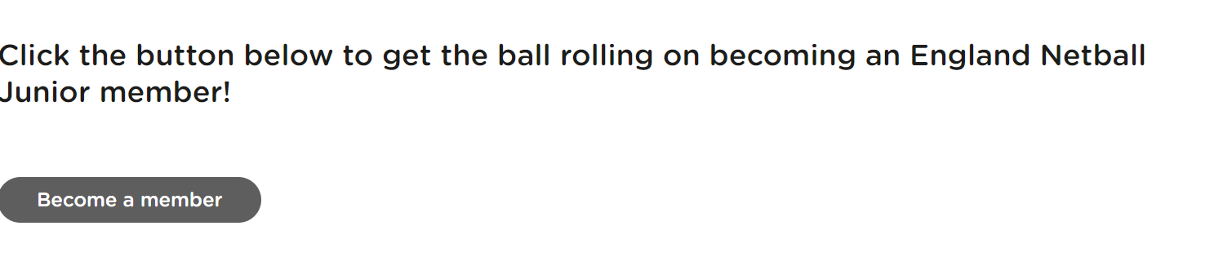
This will take you to the sign-up page (screenshot below) - England Netball | Become a Member

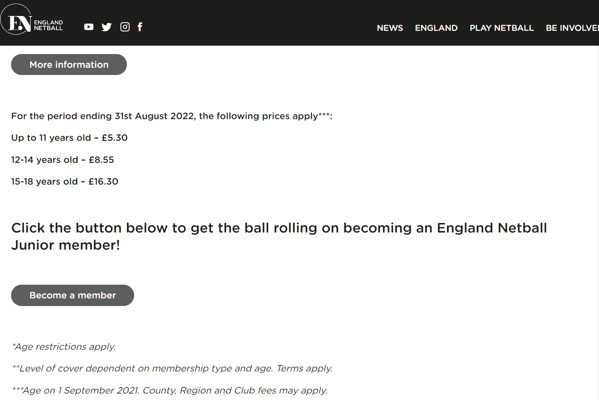

This will take you to your sign-up page where you will be asked to follow steps 1-4 to ensure your child is registered to the correct organisation. The first step will be you setting up your parent account and then you will need to link your child to your account. There is no charge as a parent.

STEP 2 – this is where you will be asked to enter your organisations name. (See screenshot below)
ORGANISATION NAME for non-Team Jets athletes: Jersey Youth NETS Club – Please enter this when asked to add an organisation.

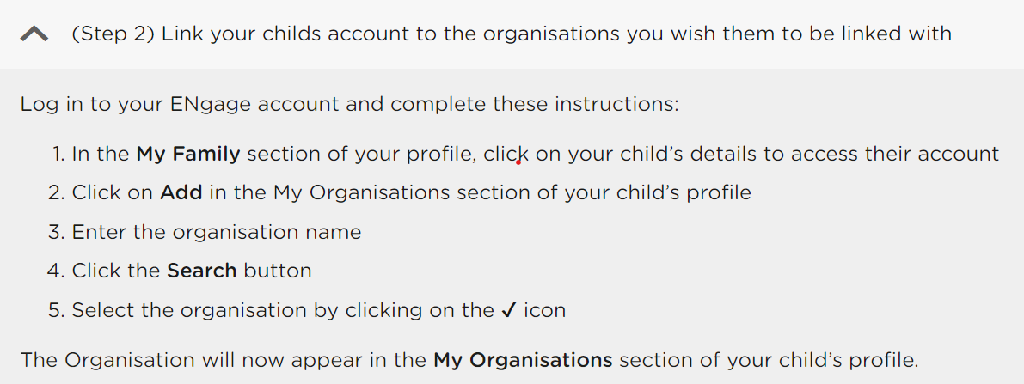

PLEASE NOTE: If you are a current member of the Team Jets performance teams, as a player or training partner please add “TEAM JETS” as your organisation when asked to add this at step 2.
JUST TO BE CLEAR YOU ONLY NEED TO SIGN UP TO ONE ORGANISATION

- NON-TEAM JETS ORGANISATION NAME: Jersey Youth NETS Club
- CURRENT TEAM JETS PLAYERS AND TRAINING PARTNERS: TEAM JETS

Youth NETS Registration
This will go live on FRIDAY 5th AUGUST 2022 12-NOON.
You can book your child on our new RaceNation booking platform and the link will be provided on Friday 5th August on the Jersey Netball Homepage so please keep an eye out for this.

Programme Information:
Location – LES ORMES SPORTS HALL
- Autumn term SEPTEMBER – 10 weeks programme starts 14th September - 23rd November.
Price: £90 - Includes Youth NETS T-shirt
- Spring term JANUARY – 10 weeks programme –starts 11th January - 22nd March.
Price: £70
- Summer term 6 weeks programme- Dates TBC

Programmes will have 6 weeks of technical and tactical learning followed by 4 weeks of competitive match play!

Wednesday Year 8 - 6pm-7:15pm
Wednesday Year 9 - 7:15pm-8:30pm
Thursday year 6 - 5:00pm-6:15pm
Friday year 7 - 6pm-7:15pm
Saturday years 7/8/9 -12:30pm-2pm – Match Play Saturdays – Open to all players not involved in the PwC County Academy.

PLEASE NOTE:
If you are unable to make your allotted age group slot, it is acceptable to book a slot for the next year group up.
If you join through the season you will need to purchase the Youth NETS T-shirt separately.

